How to run and trace a program in Eclipse version 3.3

A. Download and install JDK 6 Update 4 for windows from: http://java.sun.com/javase/downloads/index.jsp
B. Download Eclipse Eclipse Classic 3.3.1.1 from http://www.eclipse.org/downloads/. The name of the file is: eclipse-SDK-3.3.1.1-win32.zip. Unzip the file (I unzipped it into C:\Program Files), and put its short-cut icon on your desktop.
Since you will have several projects, make a folder on your drive say “Projects”. Now in “Projects” make a folder called “Project1”. In the following I am making a project file.
Note: To read each of following pictures more clearly click on the lower right corner and drag it.

1. Double-click on the eclipse icon on the desktop (or in C:\Program Files\eclipse). Click on Browse and find the folder Project1. You see the following figure:

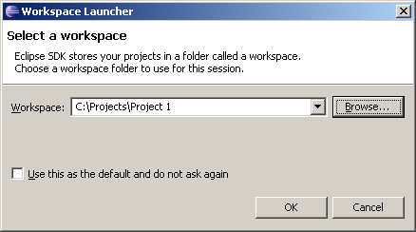

2. Click OK to get:

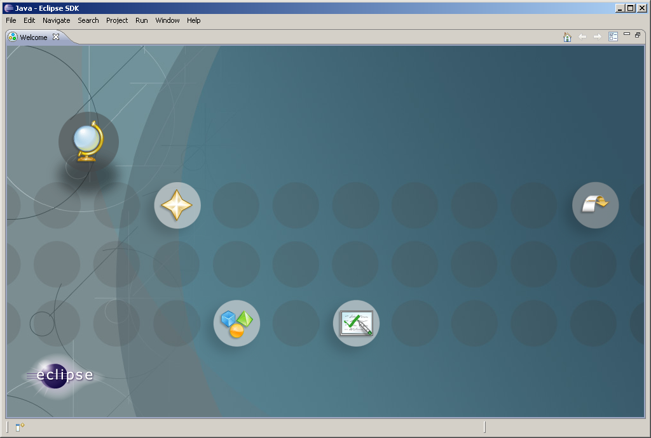

3. on the upper left corner click on to close the Welcome to Eclipse to get (You can bring this window back from the help icon):

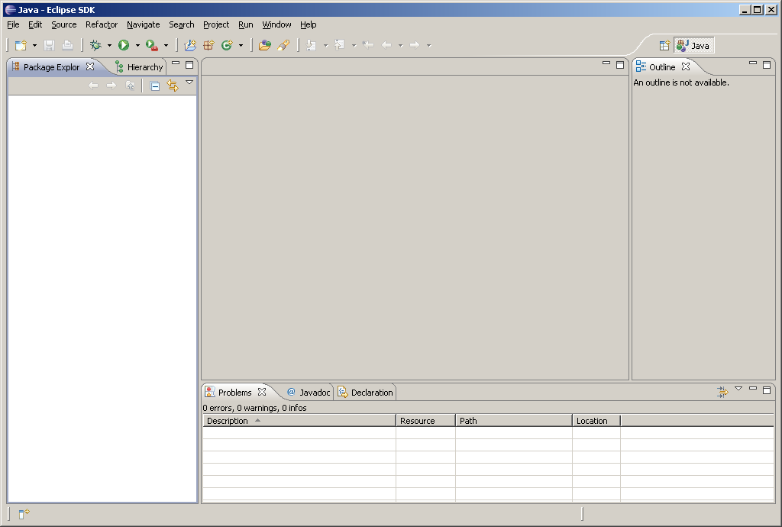
4. We now create a project file. Click on File → New → Java Project to display the New Project wizard:

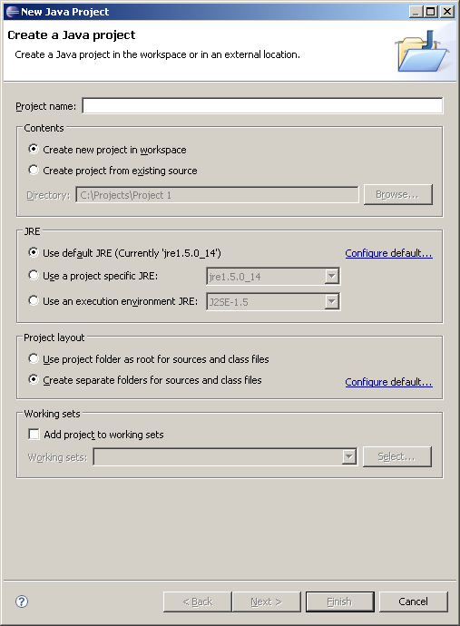

5. Type myProject1 (no space between my, Project, and 1) for the Project name field:

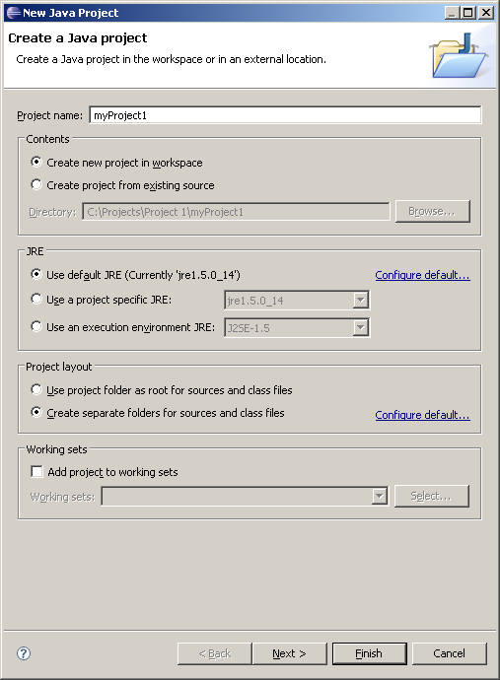

6. Make sure your radio buttons are checked according to the above picture. Click Finish to create the project. You should see:

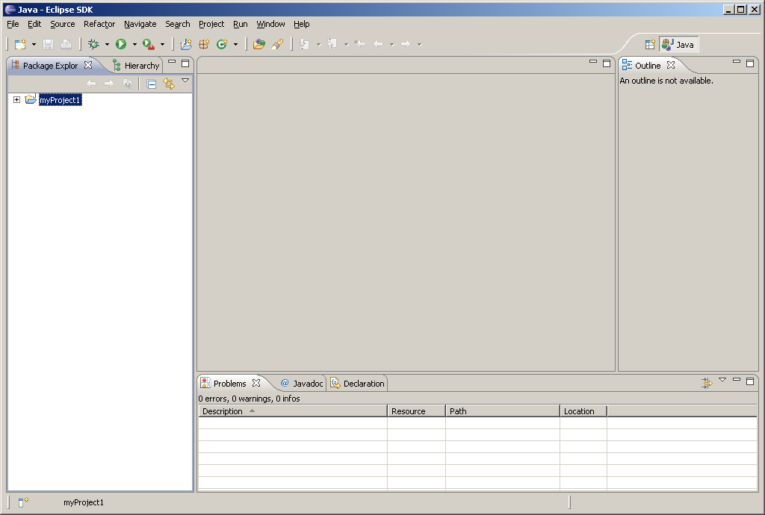

7. We now create the first program. On the upper corner click on File → New → Class:
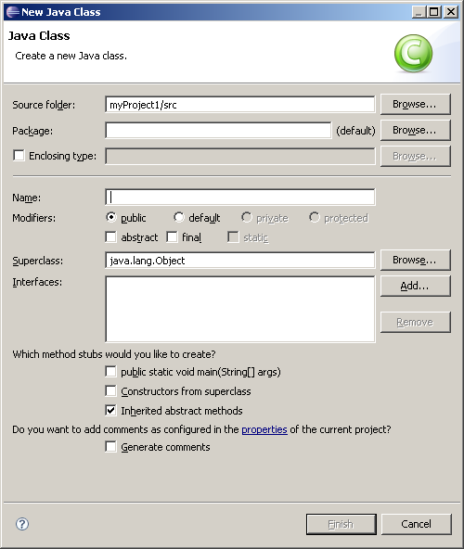

8. In window labeled Name enter Main, make the check boxes as follows:

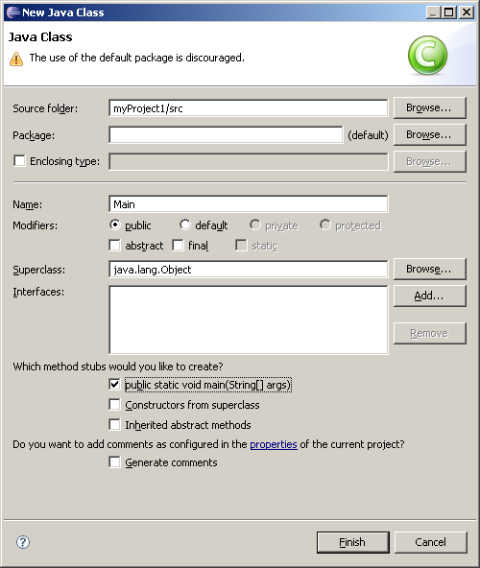

9. Click on Finish button to get:

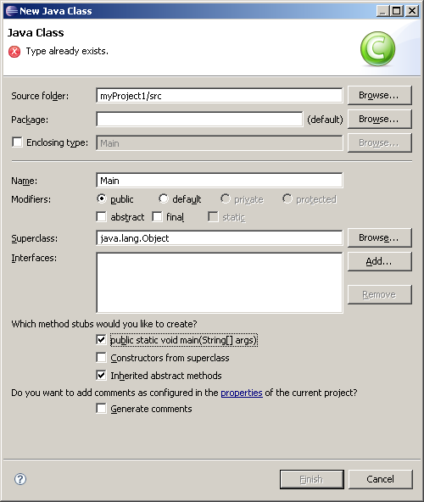

10. Delete the comments (they are useless) and enter the following instruction:

System.out.println("My name is John Doe.");

Make sure you entered a semicolon at the end of the instruction. You should have the following in the editor:

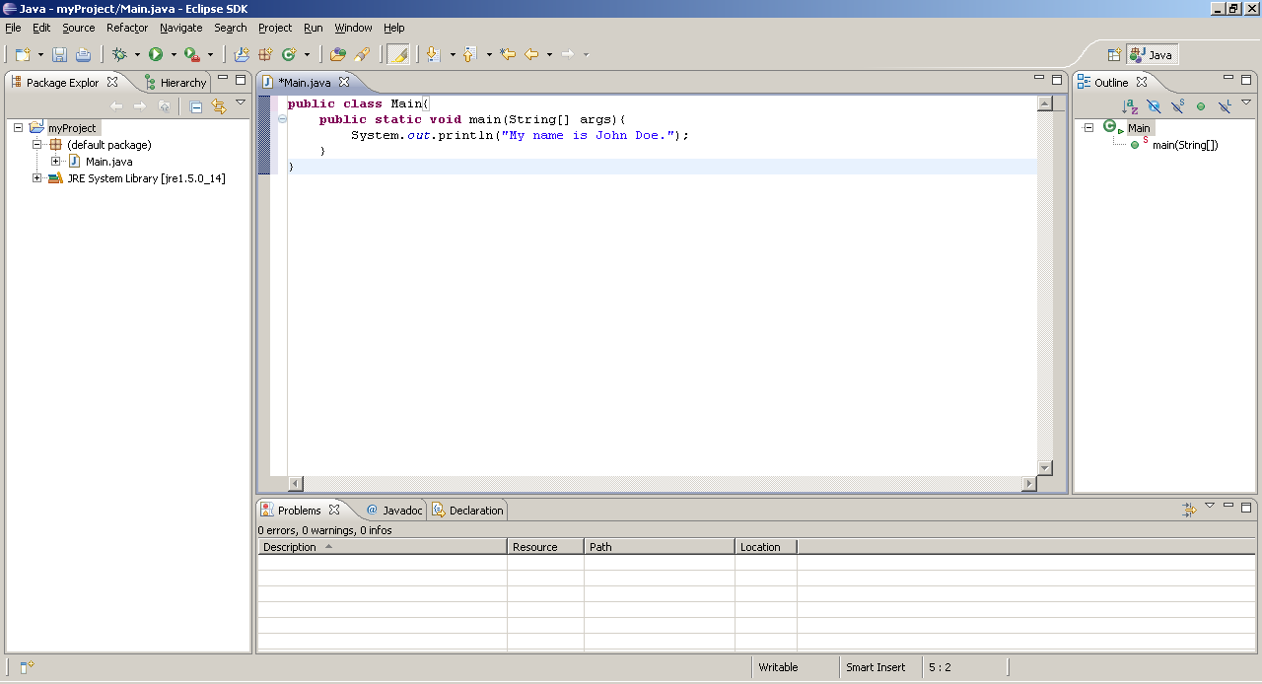

Click on on the menu bar to save your program.

11. You do not need to compile the program. As you type the program Eclipse compiles it. When a java program is compiled creates a file with extension class. Take a look at folder C:\Projects\Project 1\myProject to see there is a file Main.java and Main.class. The Eclipse compiler translates every java file to a class file. The content of Main.class is called byte codes. The java interpreter executes this file and displays output of your program. In case you have errors in your program Eclipse dynamically checks the syntax errors. To run the program on the menu bar click on Run → Run As to see:

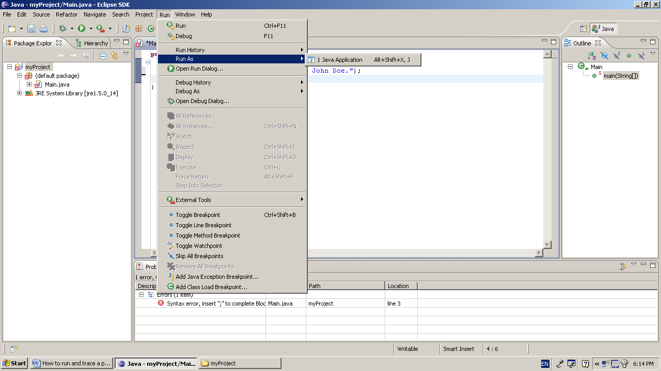

12. Click on 1 java Application to see the output of the program (My name is John Doe.) in the lower window:

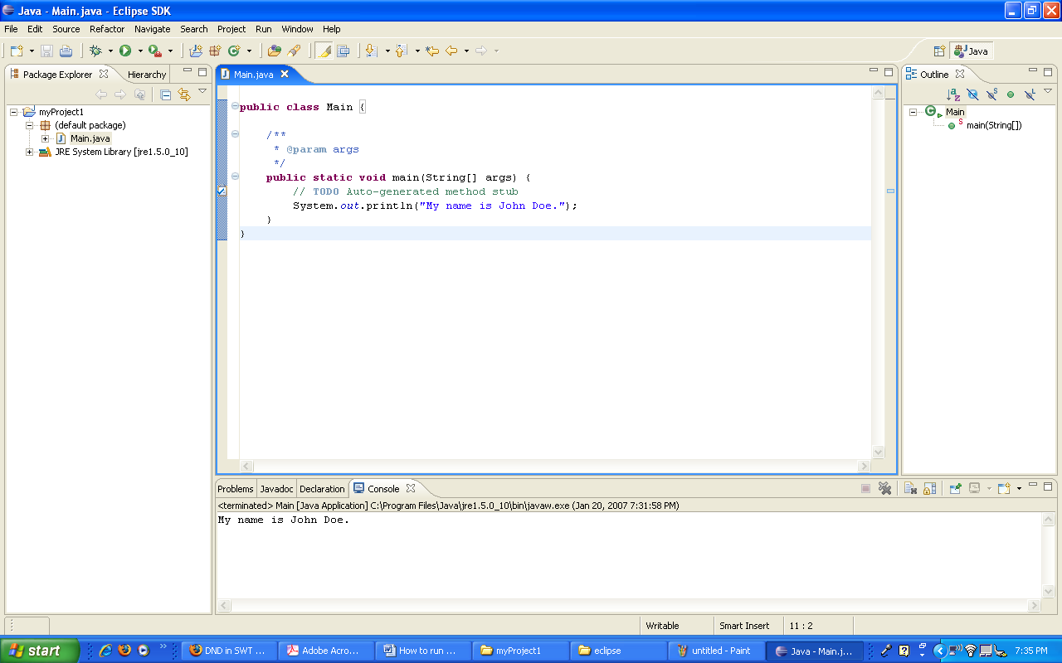

Note: Once you run the program you do not need to run it this way. You can click on on the menu bar.
13. Click on File → Exit to exit from eclipse.

As you are going through the course, you program will consists of several classes (java files). In the following subject we first make a program with two classes and then debug it.

A program with more than one class Eclipse

1. Create a second folder name Project2 in the folder Projects. Click on the icon Eclipse to activate it.
2. Make a project folder named myProject2, by following steps 1-6, but for the folder Project2.

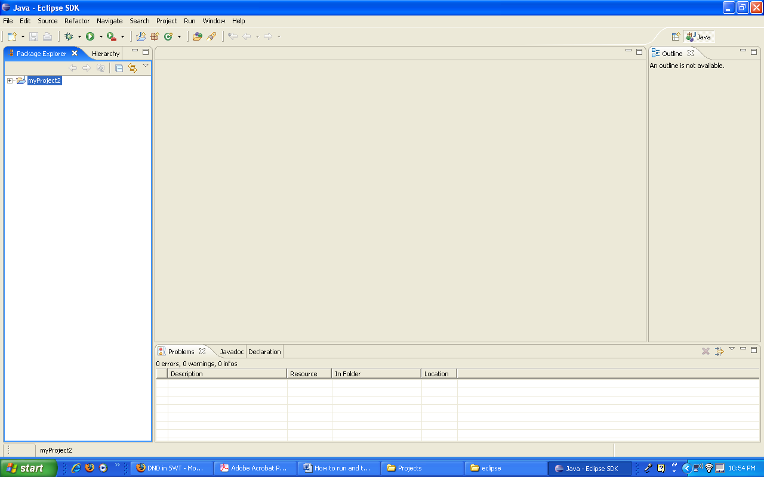

3. Follow steps 7 to 9 to make the first class (java file). Name this java file Main as you did before. Main.java is your first class (java file).
4. We now create the second class. On the upper left corner click on File → New→ Class. Type Second for the name of the class and uncheck the check box labeled public static void main(String[] args). You should have:

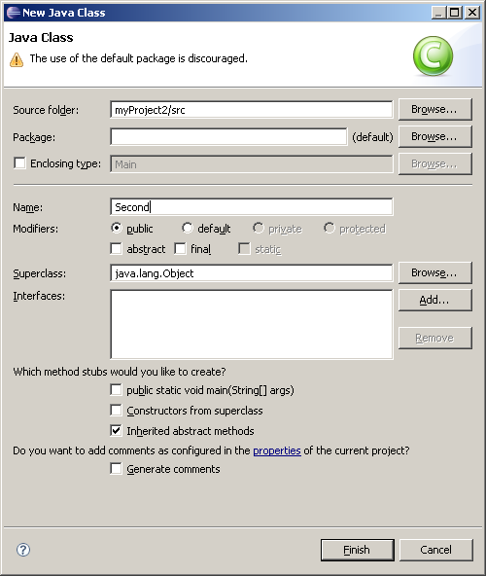

Click on Finish to get:

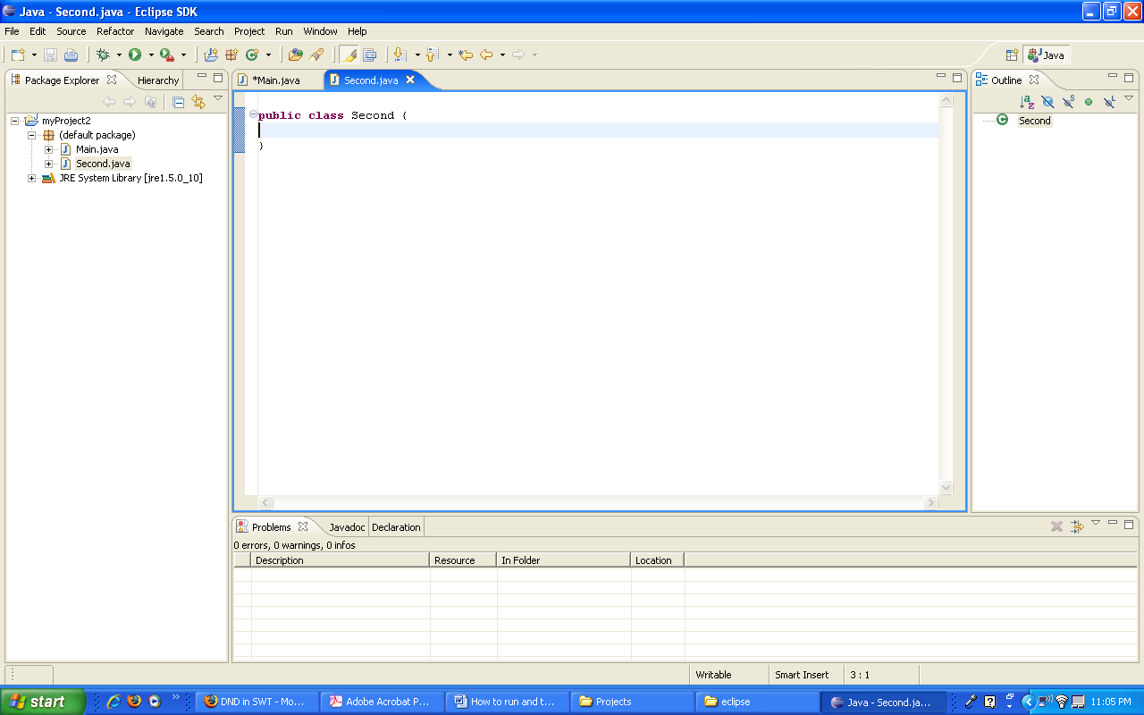

You now have two empty classes. I am going to make a method for the second class with some code that you will learn them later. The purpose of this lecture is to learn how to make a program and how to trace it. You will learn java through the semester (this sentence is for students who do not know java at all).
Note: Its is customary to type the name of a class starting with upper case letter and type the name of a method (like main) in lower case letters.

5. Replace the content of the second class by the following:

import java.util.Scanner;

public class Second {
public void sum(){
int m = 0, n;

Scanner key = new Scanner(System.in);
System.out.println("Enter a positive number: ");
n = key.nextInt();
for(int i = 1; i <= n; i++)
m = m + i;
System.out.println("The sum of 1 + 2 + .... + " + n + " is: " + m);
}
}

Your editor should look like:

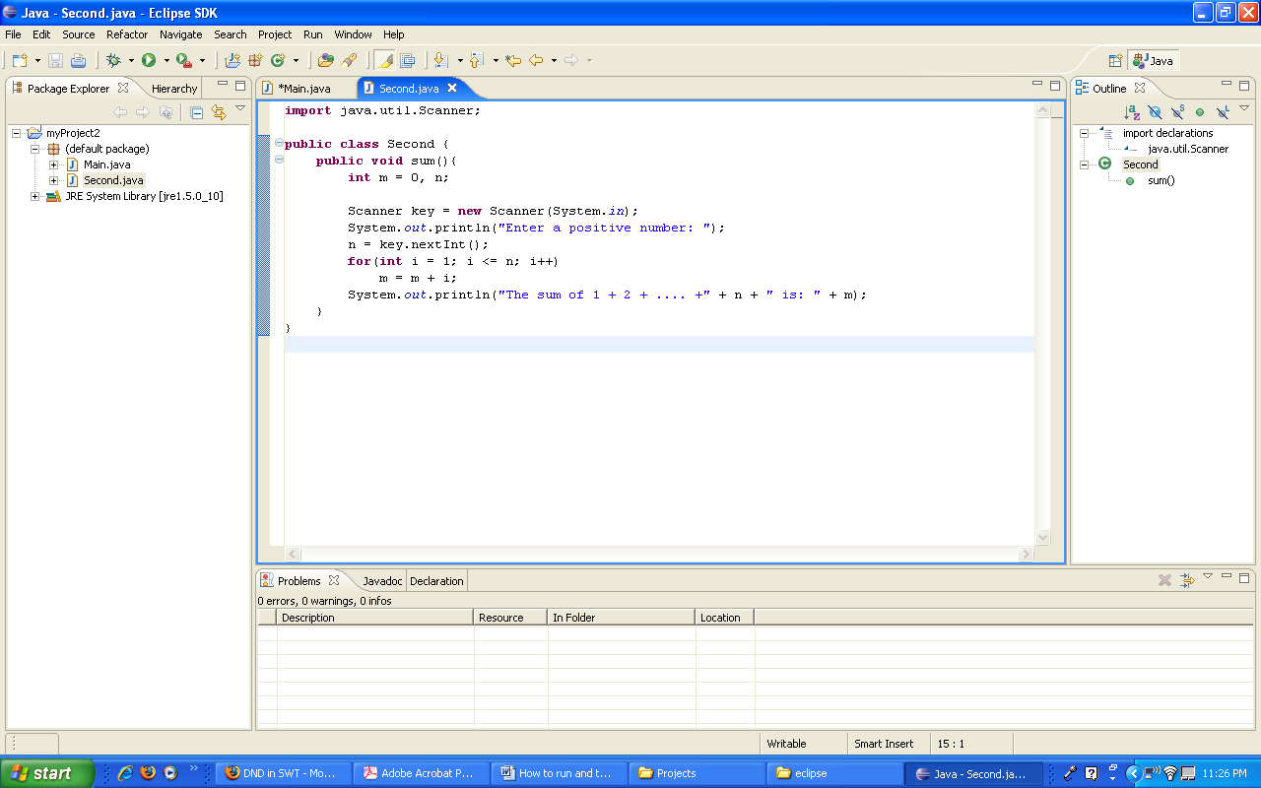

Note: Indentation is important. We use tab key for indentation. As your classes get bigger and bigger indentation of the lines make your program:
- More readable.
- Easier to trace and debug.

Therefore from the beginning indent all lines of your classes. If you do not indent your classes from the beginning changing you habit to impose indentation is not easy.

6. Click on main on the menu bar to bring the class Main.java on the screen. Add the following code to method main (copy and paste):

Second x = new Second();
x.sum();

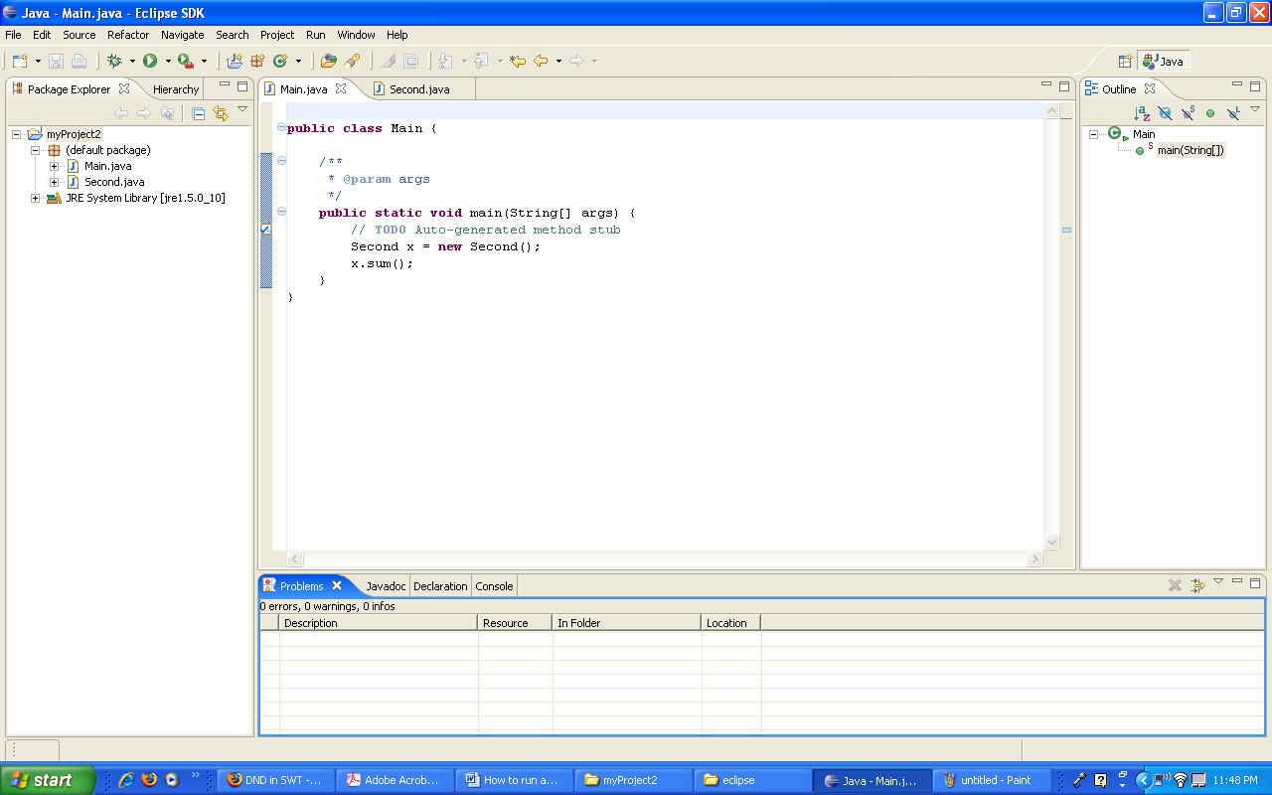

7. Like the first project run this project.:
The console icon in the lower window is high lighted and the message Enter a positive number: shows up. Enter a number (like 5) and hit Enter key. The output of the program shows up.

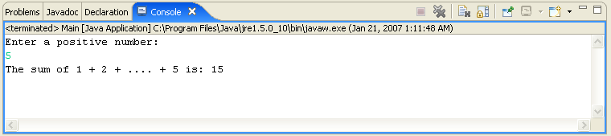

Tracing a java program

There are times you make a program, run it but you do not get the desired answer. In this situation you need to trace your program and look at the value of your variable. First we trace the program instruction by instruction.

1. Click on Window → Open Perspective → Debug to get:

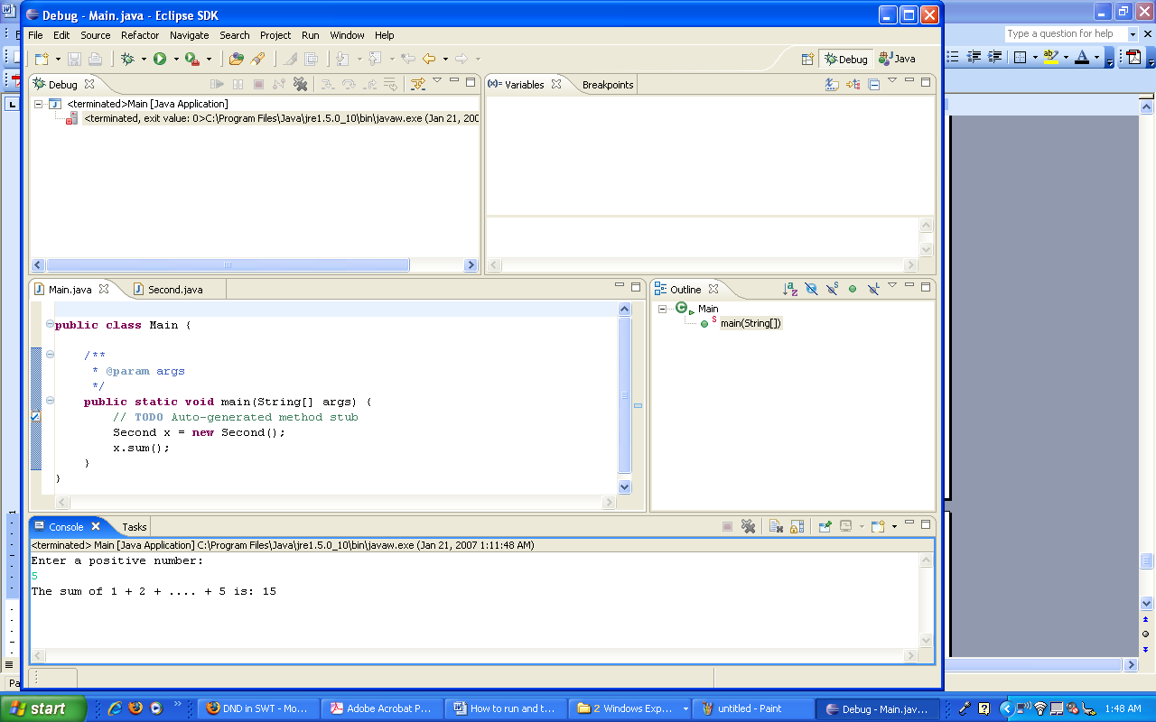

Temporary make this picture bigger to see the purpose of each window.

2. In the class Main on the margin of the first instruction right-click:

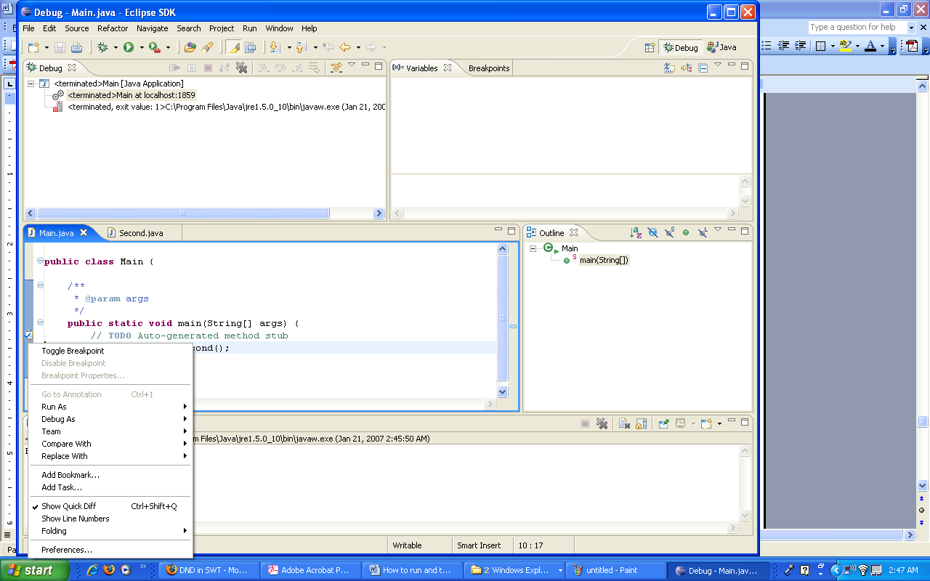

3. Select Toggle Brakepoint. You should see a small circle on the margin:

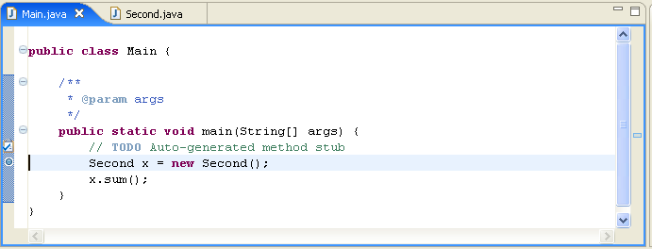

4. on the menu bar click on Run (not on ) to see the following window. Click on Debug As and select 1 Java Application. Click on Run and look at the window:

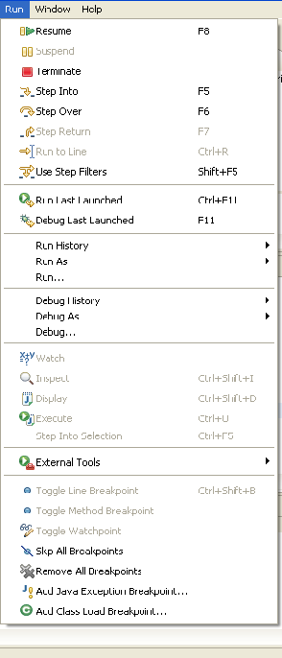

Let us take look at some of the items in this window:

Resume resumes the execution of a paused program.
Suspend temporarily stops execution of a program.
Terminate ends the current debugging session.
Step Into executes a single statement or steps into a method.
Step Over executes a single statement. If the statement contains a call to a method, the entire method is executed without stepping through it.
Step Return executes all the statements in the current method and returns to its caller.
Run to Line runs the program, starting from the current execution point, and pauses and places the execution point on the line of code containing the cursor, or at a breakpoint.
Note: I know some of the terms such as method, call a method, return to a caller is not clear. Be patient, I will explain these terms and more through the semester (this paragraph is for the students who are new to Java).

5. Hit F5 (Step Into) several times and look at the top-right window to see the value of the variables. Once you passed the instruction n = key.nextInt(); enter a number (like 5) in the lower window.

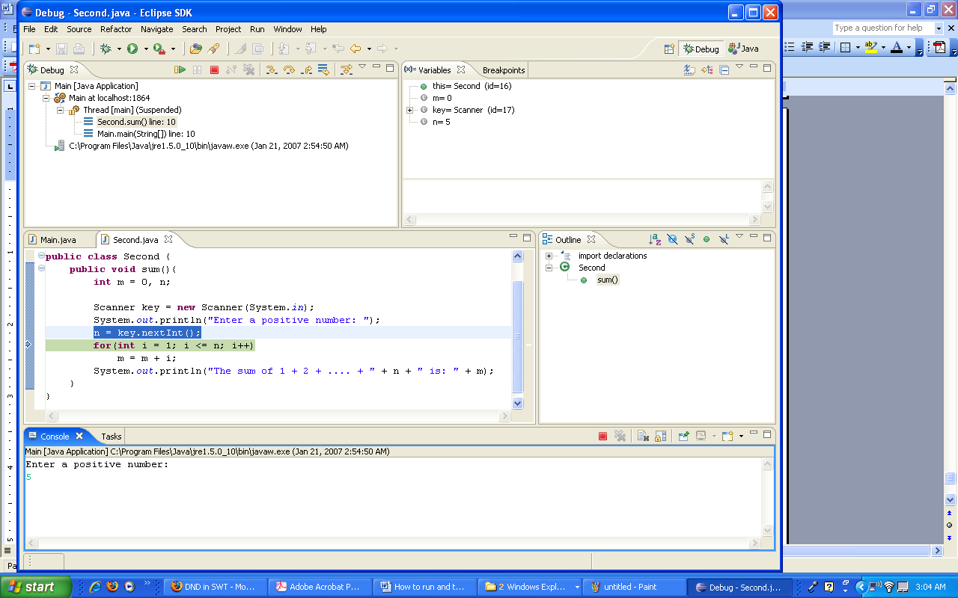

Note: Enlarge this picture to see the lines more clearly.
Look at the Variables window to see the value of the variables. The second and fourth line are understandable. At this stage the value of the variables m and n are 0 and 5 respectively. Keep hitting F5 and watch the value of the variable.
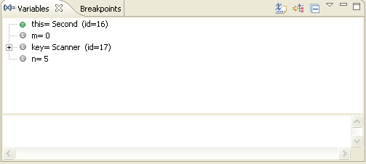

Eventually the execution of program is terminated and you see:

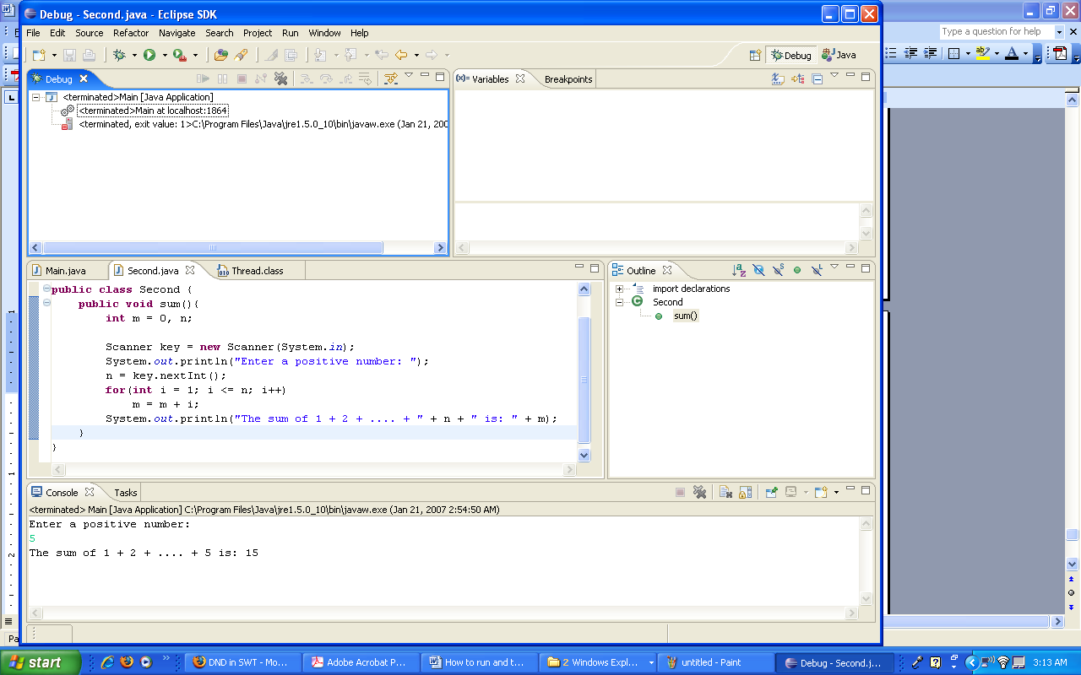

If the program does not terminate at this stage click on the small red-icon on the menu bar.

You saw one application of a breakpoint. Another application of breakpoint is for the time you are sure part of the program is correct. In this situation make a breakpoint after this part.
Note: To remove a breakpoint point to it, right-click, and select Toggle Breakpoint.
6. Click on Main.java icon to activate the Main class and remove its break point.
7. In class Second make a break point on the margin of the instruction:
System.out.println("The sum of 1 + 2 + .... + " + n + " is: " + m); the window for Second.java look like:

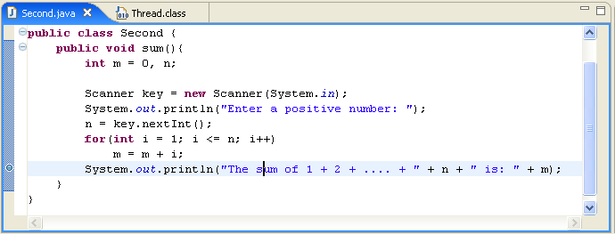

8. on the menu bar click on Run and click on Debug Last Lunched (or hit F11) and enter 5 to see:

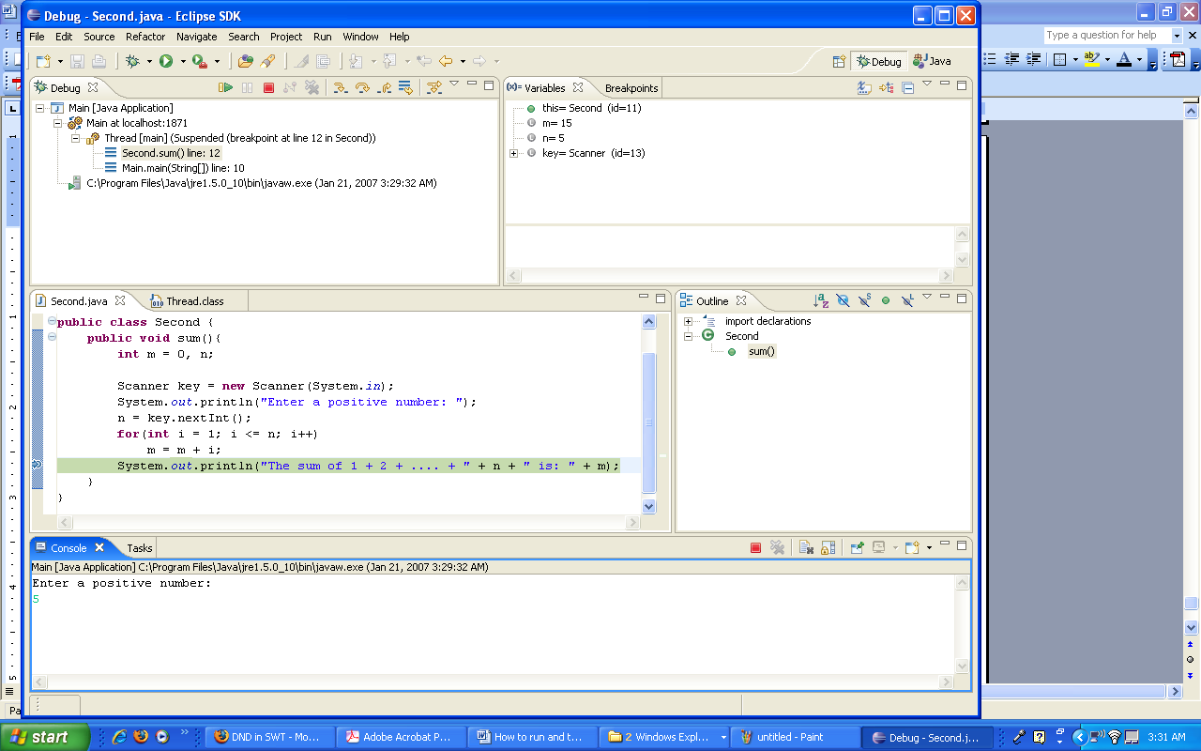

Note that the execution of the program stopped on the breakpoint. See the value of the variables.
9. on the menu bar click on the small red icon to terminate the execution of the program.

